A study about French counties and house prices

For the IBM Data Science Professional Certificate

September 1, 2020

by SAUBA Ashish

Contents

2. Introduction 2

Disclaimer: 2

Context: 2

Project goal: 2

3. About the data 3

Commune’s geographical data of 2013 3

French population age census of 2016 4

2017 French household incomes 4

Real estate transaction records 2015 to 2019 5

Foursquare’s database 6

France Geojson 6

4. Methodology 7

Notebooks 7

Overview of the data preparation 7

Exploratory data analysis 8

Searching for a “good place” 11

Using Foursquare’s database to get an insight of night life 11

Estimation of house prices in a city 12

5. Results 15

6. Discussion 15

7. Conclusion 16

# Introduction

## Disclaimer:

I made this project to practice my coding skills and the data science tools I have learned from *IBM Data Science Professional Certificate* class and other various tutorials. The results of this study should be taken as mere insight.

## Context:

This year, the COVID-19 pandemic hit France severely and induced a national lockdown of more than 2 months in the country. A big proportion of France’s population lives in apartments, and since the lockdown, many are looking to move into actual houses. Moreover, with remote working, some people are willing to relocate to places where house prices are more affordable.

## Project goal:

This project is meant to answer this question:

**Where is a “good place” to buy a house in France and at what price?**

To answer this question, first we need to define “good place”. For this study, we will define “good” with those criteria:

* Population density
* Population’s median age
* Population’s median income
* Real estate price
* Nightlife

We will play with those criteria to filter places in France and pick a town or a city.

Secondly, we will estimate more precisely how much a house will cost in a specific town/city according to these factors:

* The size of the house
* The number of rooms
* The land area

The project may interest:

* People who are willing to relocate and buy a house
* Real estate agencies
* Real estate developers

# About the data

The data was collected on the internet, mainly on France’s government website.

The French territory is subdivided in many smaller administrative areas. The smallest administrative area is called a *Commune*, it is the equivalent of a *county* in English. A c*ommune* is on average fifteen square kilometres in size. A *commune* is the smallest division of land provided by the French government websites.

All the data obtained is in French, therefore here is the translation of some the terms encountered:

*Commune*: County

*Code INSEE*: County’s ID as per the French government’s statistics department (INSEE)

*Revenue*: Household income

*Valeur foncière*: Real estate value

*Vente*: Sale

*Maison*: House

*Surface Carrez*: Living area

*Surface terrain*: Land area

*Nombre de pièces principales*: Number of main rooms

Here are some details about the data used for this project:

## Commune’s geographical data of 2013

* Source : <https://www.data.gouv.fr/en/datasets/correspondance-code-insee-code-postal/>
* File name: correspondance-code-insee-code-postal.csv
* Provider: Région Île-de-France
* Number of rows: 36 742
* Contains: Geographical information for each Code INSEE (county Id)
* Main feature used:
  + - *Communes’* names
    - Latitudes and longitudes
    - Communes’ surface
* Used for:
  + - Locating the *Communes*
    - Estimating the *Communes* population density
* Pre-processing:
  + - A quick data-pre-processing allowed us to extract the information needed
* Notebook about the pre-processing: <https://nbviewer.jupyter.org/github/Ashish-3/House-prices-in-France/blob/master/Preprocessing_communes_stats.ipynb>

## French population age census of 2016

* Source : <https://www.data.gouv.fr/fr/datasets/population-municipale-t-popmun-com/>
* File name: t_popmun_com.csv
* Provider: Atlasanté
* Number of rows: 7 million (approximately)
* Contains: One row for each combination of age, sex, and *Commune*
* Main feature used:
  + - Age count per *Commune*
    - *Code INSEE*
* Used for estimating in each *Commune*
  + - The population
    - The density of population
    - Statistics about the age (median age)
* Pre-processing:
  + - A quick data-pre-processing with some sums allowed us to extract the information needed
* Notebook about the pre-processing: <https://nbviewer.jupyter.org/github/Ashish-3/House-prices-in-France/blob/master/Preprocessing_communes_stats.ipynb>

## 2017 French household incomes

* Source : <https://www.insee.fr/fr/statistiques/4507225?sommaire=4507229>
* File name: cc_filosofi_2017_COM.CSV
* Provider: INSEE –Filosofi
* Number of rows: 34 931
* Contains: One row per *Commune* which describes households’ incomes
* Main feature used:
  + - *Revenue* median
    - *Revenue* inequalities
    - Number of households per *Commune*
* Notebook about the pre-processing: <https://nbviewer.jupyter.org/github/Ashish-3/House-prices-in-France/blob/master/Preprocessing_communes_stats.ipynb>

## Real estate transaction records 2015 to 2019

* Source : <https://www.data.gouv.fr/en/datasets/demandes-de-valeurs-foncieres/>
* Files names: valeursfoncieres-2019.txt

valeursfoncieres-2018.txt

valeursfoncieres-2017.txt

valeursfoncieres-2016.txt

valeursfoncieres-2015.txt

* Provider: Ministère de l'économie et des finances
* Number of rows: 14.8 million in total (approximately)
* Contains:
  + - One row for each real estate transaction
* Main feature used:
  + - *Commune*
    - Real estate value *(Valeur foncière)*
    - Type of estate: house (*maison*), apartment, outbuilding (*dépendance)*…
    - Living area (*Surface Carrez)*
    - Land area (*Surface terrain)*
    - Number of main rooms (*Nombre de pièces principales*)
* Used for:
  + - Estimating the price of houses per meter square for each *Commune*
    - Build a price estimator for houses in a specific area
* Pre-processing:
  + - We filtered the transaction and kept only transactions:
      * concerning sales
      * concerning houses
        + with no outbuildings
        + and with less or equal to 1000m² of land surface
        + and with less or equal to 200m² of living area
        + and with less or equal to 10 main rooms
    - Many duplicates existed in the data frame, for instance outbuildings of a house sale were listed as a separate transaction but with the house price. A gross approach was used to remove most, if not all, of the duplicates.
    - Some empty land area fields were replaced with the living area
    - Some empty living area fields were replaced with the building’s base surface
    - The names of the *Communes* in the DataFrame had to be corrected so it matches the other datasets. This step allows us to merge different DataFrames together.
    - The remaining DataFrame consisted of only 1.6 million transactions. Those transactions were then used to:
      * generate a 32 567 rows DataFrame of statistics of houses per *Commune*
      * build a house price estimator in any chosen *commune*
* Notebook: <https://nbviewer.jupyter.org/github/Ashish-3/House-prices-in-France/blob/master/Preprocessing_house_transactions.ipynb>

## Foursquare’s database

* Source : Foursquare API
* Provider : Foursquare Labs Inc.
* Description: Foursquare has a database of restaurants, bars, companies, and other venues that can be accessed through API calls. With a free Developer account, a limited amount of calls can be made.
* Used for: Getting the number of bars in *Communes* as a nightlife indicator. To minimize the number of API calls we made, Foursquare’s database was used only on a pre-sorted list of *Communes*.
* API calls used: Search endpoint using the category ID of “bars”
* For more info: [*https://en.wikipedia.org/wiki/Foursquare_City_Guide*](https://en.wikipedia.org/wiki/Foursquare_City_Guide)

## France Geojson

* Source: <https://github.com/gregoiredavid/france-geojson>
* File name: communes-version-simplifiee.geojson
* Provider: Gregoire David
* Contains: Polygon lines for each *Commune*
* Used for: Plotting choropleth maps

# Methodology

## Notebooks

The project details can be found in four separate notebooks:

* Pre-processing data about the communes

<https://nbviewer.jupyter.org/github/Ashish-3/House-prices-in-France/blob/master/Preprocessing_communes_stats.ipynb>

* Pre-processing the real estate transaction records

<https://nbviewer.jupyter.org/github/Ashish-3/House-prices-in-France/blob/master/Preprocessing_house_transactions.ipynb>

* Data analysis

<https://nbviewer.jupyter.org/github/Ashish-3/House-prices-in-France/blob/master/Communes_analysis.ipynb>

* Estimating house prices in Clermont-Ferrand

<https://nbviewer.jupyter.org/github/Ashish-3/House-prices-in-France/blob/master/House_prices_modeling.ipynb>

## Overview of the data preparation

First, we started pre-processing the data about:

* The geographical information of the *Communes*
* The population and its age
* The income of households

And then we merged them all in a single DataFrame.

Secondly, we studied the real estate transactions. It was pre-processed separately because of its size and the amount of work needed. This was then used to create house statistics per *commune* DataFrame. Thirdly, we combined all the data gathered in one single DataFrame.

Here is a summary of the pre-processing step:

Figure : Summary of the data pre-processing step

## Exploratory data analysis

Once all of the preparation is done; we could then visualise how the different indicators varie across the French territory. With the help of a Geojson file which mapped all the *Communes* of France, we created several maps:

* Map of the population density
* Map of the standard of living (median revenues of households)
* Map of the population’s age (median age)
* Map of house prices per metre square (average value)

The interactive maps (html versions) can be downloaded from here for better viewing experience:

<https://github.com/Ashish-3/House-prices-in-France/tree/master/maps>

For a quick preview of the maps, here are some screenshots:

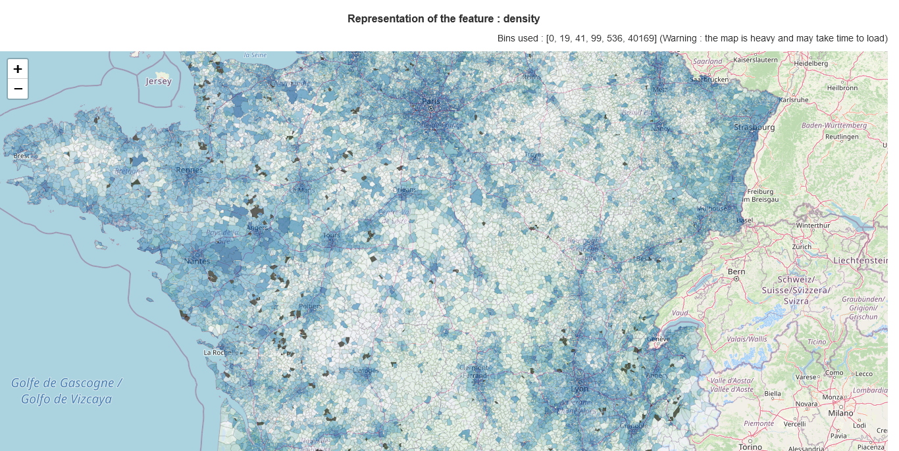

Figure : Map of the population density (screenshot)

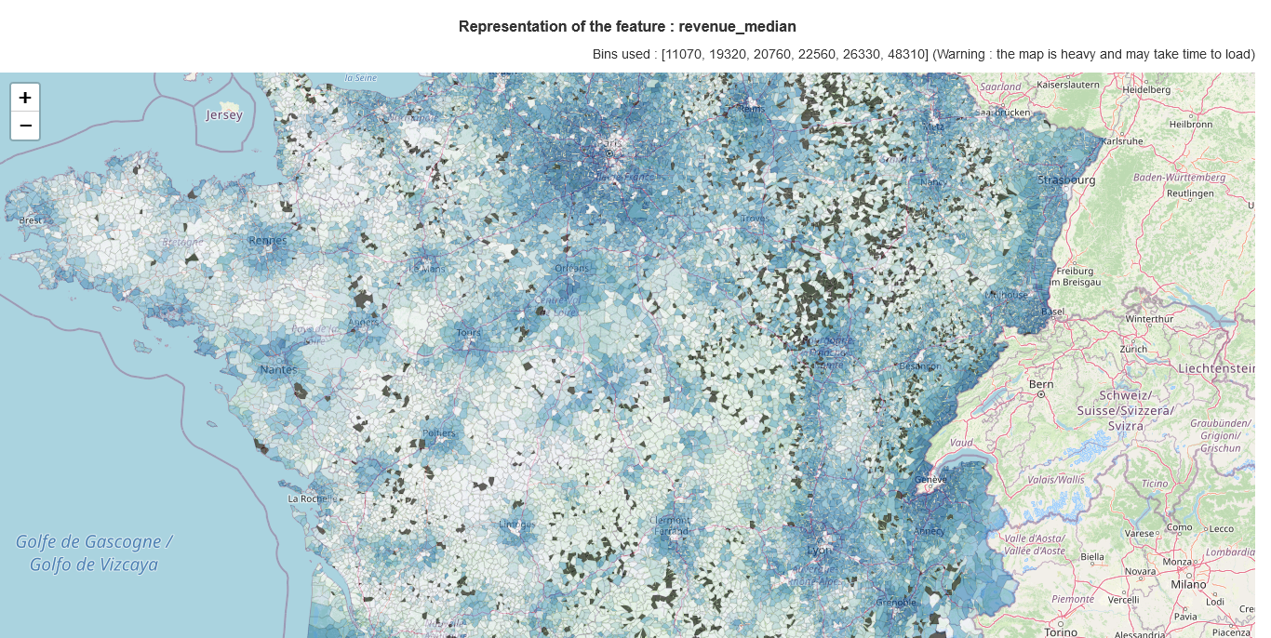

Figure : -Map of the standard of living (screenshot)

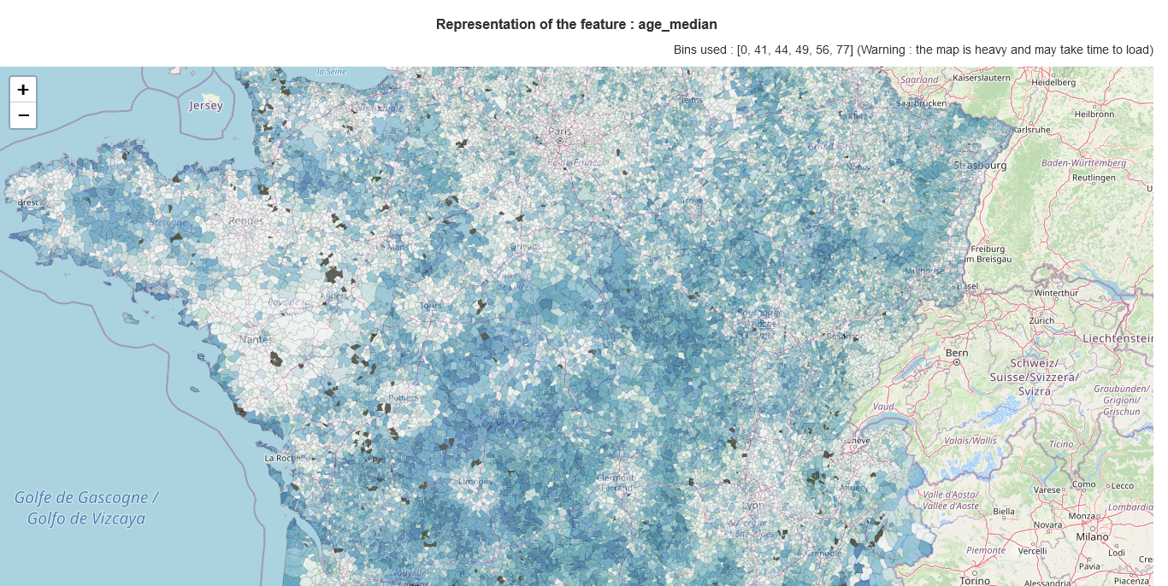

Figure : Map of the age population (screenshot)

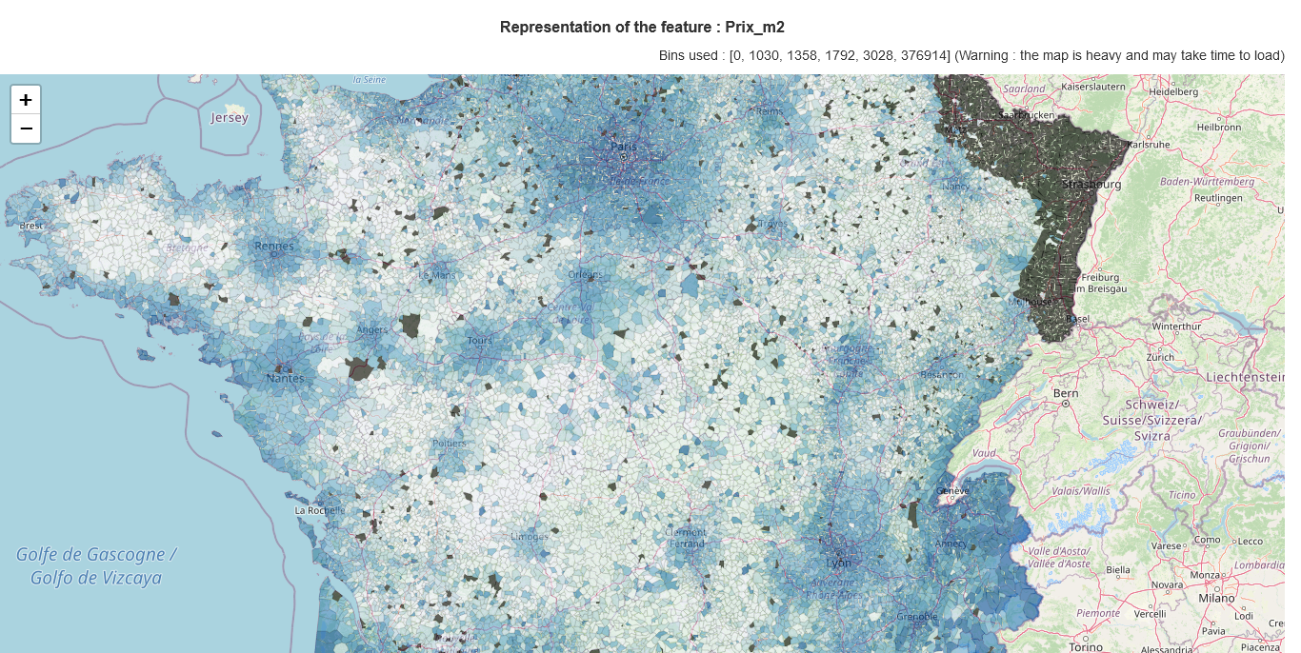

Figure : Map of house prices per metre square (screenshot)

To better understand how the Communes are distributed along the studied features, a small figure has been created which represents the distribution of the *communes* according to the different features. The style of the box plot used here is called "Letter value plots".

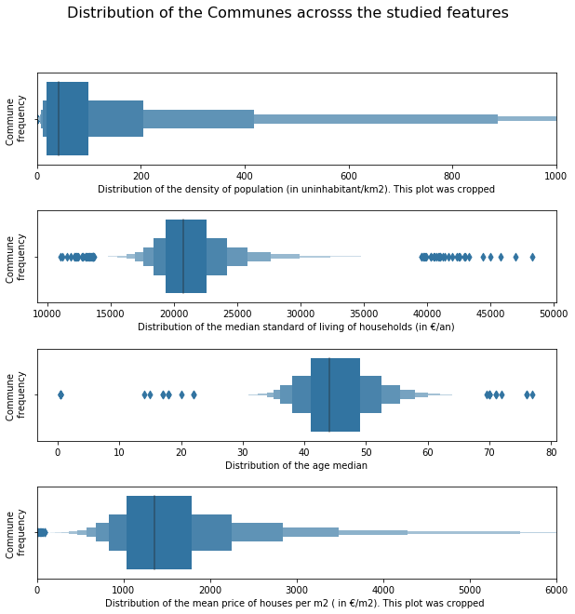

Figure : Distribution of the communes

## Searching for a “good place”

We can now start searching for a place to buy a house with different indicators. For this purpose, a small tool has been built which allows us to easily filter the c*ommunes*. If we filter the data with the tool, we can view places:

* With a dense enough population minimum of 2000 person per km2
* With a relatively young population maximum age median of 41 years old
* With a decent income minimum standard of living of 18k€
* With a fair house price max. average of 2300€/m² for houses

With these parameters we can see that only 35 places satisfy these conditions. Here is a screenshot of the tool:

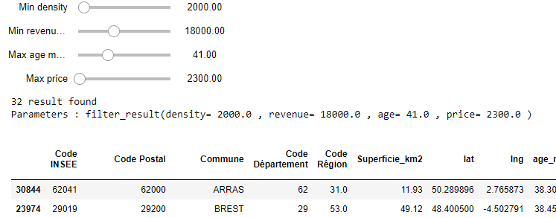

Figure : Screenshot of the filtering tool

## Using Foursquare’s database to get an insight of night life

Once we have limited the number of c*ommunes*, we can use the Foursquare API to gather information about these areas. We did a Foursquare search of available bars in the list of c*ommunes* found previously. We sent a request to retrieve venues with the category ID for bars, in a radius of 3km from the centre of the c*ommunes*.

If we consider the presence of bar as a good indicator of nightlife, we can see a good contrast between some *Communes*. Clermont-Ferrand stands out with 50 bars which is the maximum amount of venues that the Foursquare API can return in single call. We can say that, through all the filtering, Clermont-Ferrand stands out!

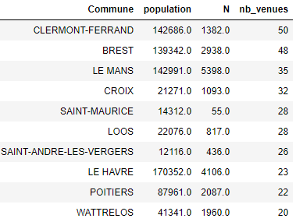

Figure : Filtered communes sorted by the number of bars available

## Estimation of house prices in a city

We have seen that Clermont-Ferrand stands out regarding our filtering criteria. Let us study the actual house prices in Clermont-Ferrand. After filtering the house transactions of Clermont-Ferrand, here is a quick overview of the distribution of transactions:

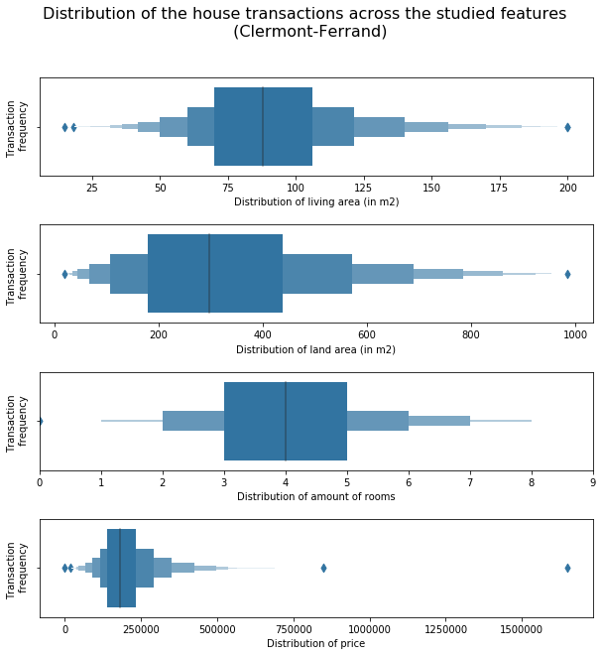

Figure : Distribution of filtered house transactions in Clermont-Ferrand

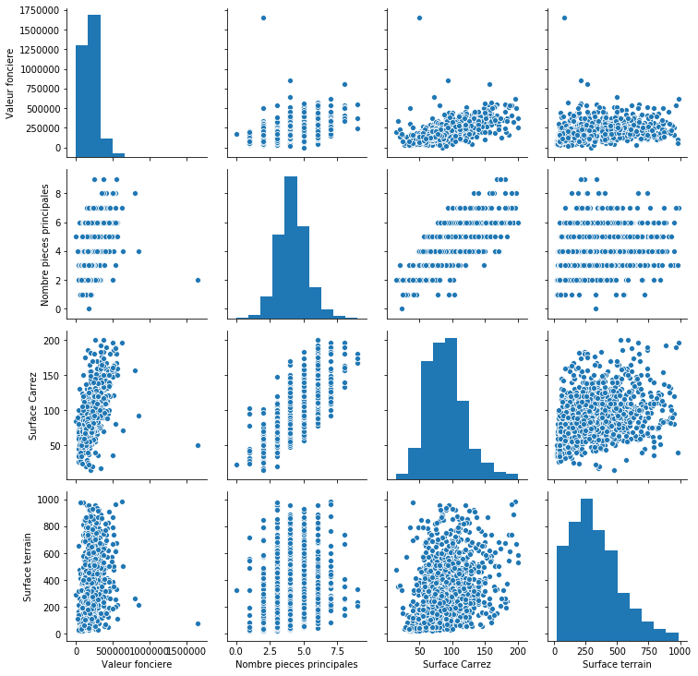A quick analysis with a correlogram shows that the price of houses is correlated to the number of rooms, land area and living area:

Figure : Correlogram of the house transactions features

From those features and using machine learning, we have built a model which predicts house prices. Different models can be used for such predictions, but the most common and simple ones are multiple linear regression, polynomial regression, and ridge regression.

To choose between these models, we have split the 1209 house transactions of Clermont-Ferrand in a training set and a testing set with a 70/30 ratio. For this study the training set was used to train the different models, but it was also used to tune the hyper parameters such as : data standardisation, the polynomial order (for polynomial regression) and the parameter alpha (for ridge regression).

We have tested each model with the coefficient of determination R² and the MSE score. The study shows that:

* The polynomial regression model performs better with a degree of 1 (which corresponds to a linear model)
* data standardisation does not have a significant effect on the model
* The ridge regression performs better with an alpha coefficient of 10 000

Here are the scores obtained below:

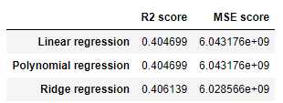

Figure : Scores of the different models

We can conclude that the difference in performance of different models is not very significant. We can also note that the best Polynomial regression is in fact a linear regression model. Hence, for the sake of simplicity a linear regression model was chosen to estimate house prices. It performs as well as (if not better than) the other models in this case study. Here is a distribution plot of the actual house prices compared to the predicted house prices:

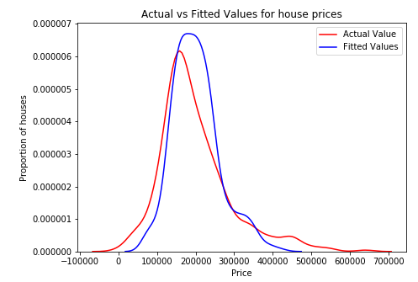

Figure : Actual values vs predicted values

After training this model on all Clermont-Ferrand’s house transactions, we have built a small tool that can predict the price of this *Commune* from the living area, the land area, and the number of rooms.

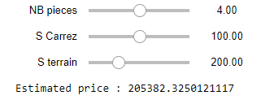

Figure : Screenshot of the price estimator tool

This tool can be used to estimate the price of different type of houses according to one’s needs.

# Results

**Where is a “good place” to buy a house in France and at what cost?**

In this study we pointed out around 35 “good places” to buy a house and we have seen that Clermont-Ferrand stands out from the other *Communes* with its nightlife. A proper model has been built by using multiple linear regression to estimate how much a house can cost in Clermont-Ferrand.

The parameters used for choosing a *Commune* can be freely modified to find a place that can better fit a person’s preferences. And the price estimator model can also estimate the price of different kinds of houses depending on a person’s preferences.

However, we have seen that the price estimator model has a coefficient of determination R² of 0.40. This score remains modest but is enough to give a quick overview of house prices.

# Discussion

This approach gave a proper overview of real estate in France, particularly houses. One of the greatest assets of this study is its flexibility. With the exact same tools, we could easily study apartments or offices, and filter the communes according to completely different criteria.

However, a more in-depth study can be done by optimising many aspects of this work. For instance, many transaction observations were lost during the data cleaning process. A less strict cleaning process could give more accurate figures and better price prediction.

One of the other aspects to be improved is the modestly low R² score of the price estimator. This score can easily be explained by the fact that the features used to train the model are not enough to explain the price of a property. For example, the age or state of the property, the safety of the borough, the proximity to transit facilities or city centres, and other factors can strongly influence the price of a property. We can note that the data also includes the address of the properties. One can easily use a geo-localisation service to analyse the distance of properties to the city centres for better prediction.

It is interesting to note that with the data collected, it could also be easy to analyse other topics such as the correlation between social and geographical indicators. For example, the correlation of the poorest households with the density of population, or the correlation of the age population and household incomes.

# Conclusion

This study shows that with some freely available data and basic data science skills, we can extract precious information about real estate choices. In my opinion this project succeeded in two ways. Firstly, the goal of the project was achieved even if there is room for improvement. Secondly, on a more personal level, this project not only allowed me to practice the skills I have learned from my classes, but it pushed me to learn more. Hoping that someday I will be able to work on even more exciting projects.